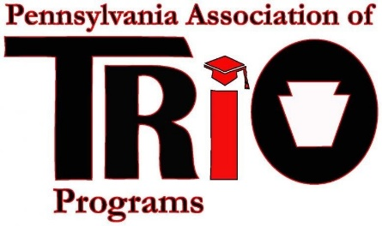
Pennsylvania Association of TRIO Programs
State Meeting (at MEAEOPP) – April 10, 2017
Public Relations Committee Report

Committee Members:
Frank DelleCurti, (Upward Bound, GECAC)

- Continuing to maintain and update the Website.
- Continuing to add and delete members from the PA TRIO Listserv
- The PA TRIO Facebook group is seeing more activity with more members joining.

Respectfully Submitted: Frank DelleCurti

